ISP Project Final Report

29 November 2020

Logan Mashchak, Ryan DeBoer, Connor Taylor

**Overview and Implementation Details**

Our project is an undergraduate degree tracker for the University of Akron Computer Science department for CS majors (systems and management tracks) as well as for the CS minor. This was a change from our previous design which was going to be a degree tracker for the College of Engineering. We cut down the extent of our data being used in order to put more time into functionality and details. The program utilizes HTML, CSS, PHP, and SQL to perform its functions. It consists of three PHP files (one for the welcome page, create account page, and main page) and a SQL file that sets up the database for the tables to set up the degree maps, the student accounts table, and the electives list.

The program starts with the welcome page (Welcome.php) asking for the user to input their user ID and select either “Log In” or “Create Account.” If they are a first time user and try to log in, it will present them with an error message and instruct them to either search for another pre-existing ID or create an account.

If they choose the route to create a new account, it takes them to a new page (Create.php). On this page they must enter their first and last name and select whether they are taking the CS systems track, management track or the minor. Based on the selection made, it will then present the classes required to fulfill that degree or minor below with checkboxes next to each course. The subject number, course number, and course name are all listed. Once the classes are selected, the user clicks the “Submit” button. Once this button is clicked, a new table is created in the database that is named with the user’s student ID that was inputted in the welcome page as a unique tracker. The information for all the courses selected is then put into that table. The student’s information is also inputted into a separate table of all the student accounts as a sort of roster.

After creation of a new student account or the login of a previous student, they are then directed to the main page (Main.php). The student can select from the choices of seeing the course they have taken so far, see the courses they still need to take, or to add additional courses that they have taken already to update their unique student table. When adding the courses, a class list plus electives will present itself with checkboxes. The user must then click the button “Update classes” to save the changes. When the user wants to see the class taken, it will display the major/minor core courses and then electives separately. It will also record how many elective credits still need to be taken; 18 elective credits for CS majors and 6 for the CS minor.

**Group Contributions**

Ryan DeBoer

* Helped writing the progress report
* setup and designed the layout of the coursesCS.sql file to organize the class data pulled directly from the department website, aided in writing the progress report

Logan Mashchak

* Helped writing the progress report
* wrote the code for the welcome.php file and did the beginning steps of main.php and create.php

Connor Taylor

* Helped writing the progress report
* Added in CSS elements to php files, designed system diagram for PPT

Joint Effort

* Using the Microsoft Teams screen control feature, we collectively worked on main.php and create.php to troubleshoot, add configurations to the project, and try to break the program to find possible sources of error
* Using a Google drive, we collectively wrote this final report paper and powerpoint to ensure all the information and implementation information was written and free of errors

**Lessons Learned and Possible Future Work**

By working jointly through Microsoft teams, we were able to effectively create a design team meeting room as we all worked together writing different sections of code while other members would learn more into different ways to improve upon the implementation through searching through learning resources on the internet and our textbook. We were also able to gain a better understanding of separate implementation of files and an increased breadth and depth of knowledge in regard to front end development. Each group member brought their own insight from various classes and internship/co-op work that enabled us to have a good group cohesion overall to develop this project.

For a future project, we think we could be able to adapt this to larger departments and more of them if we expanded the information available in the database to access.

**Screenshots for Reference**

**Figure 1: Welcome.php screen**

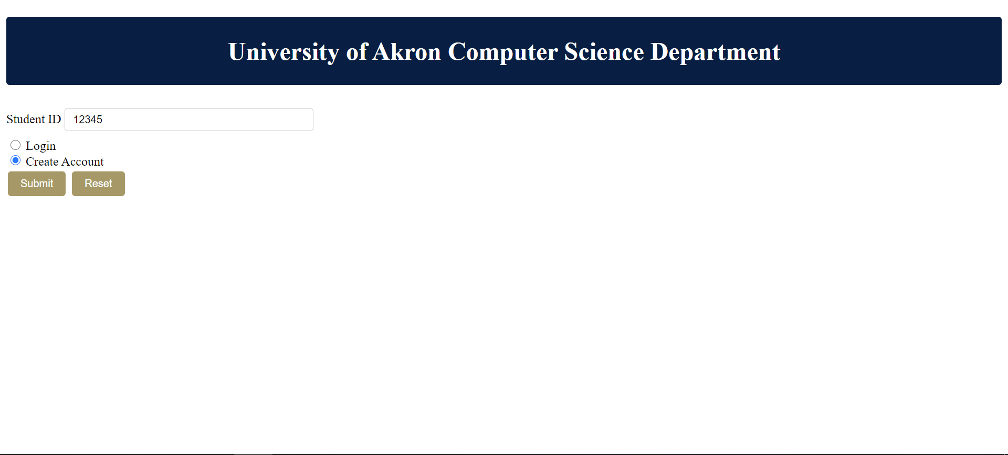

**Figure 2: Create.php name and major to create account**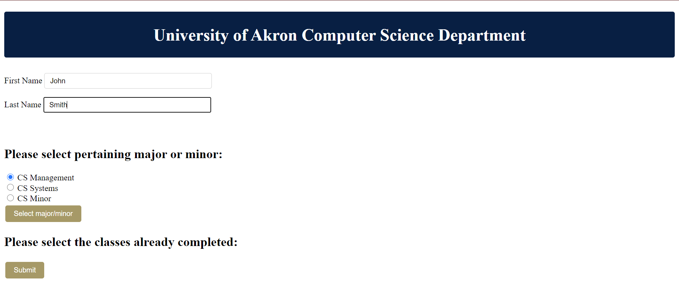

**Figure 3: Create.php selecting taken classes**

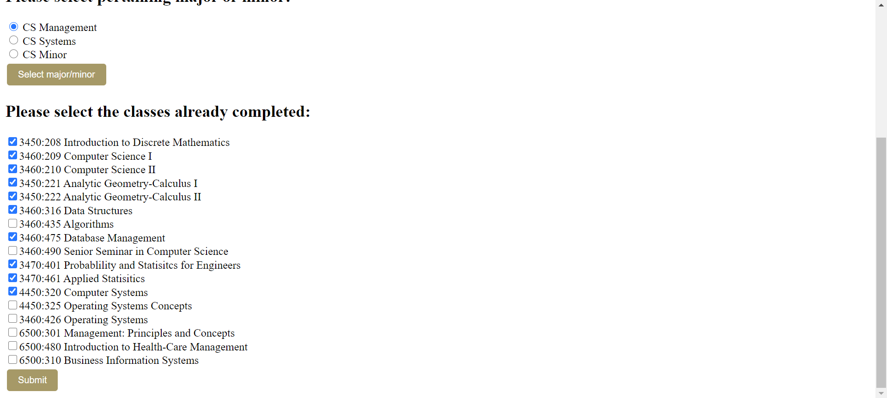

**Figure 4: Main.php display classes taken**

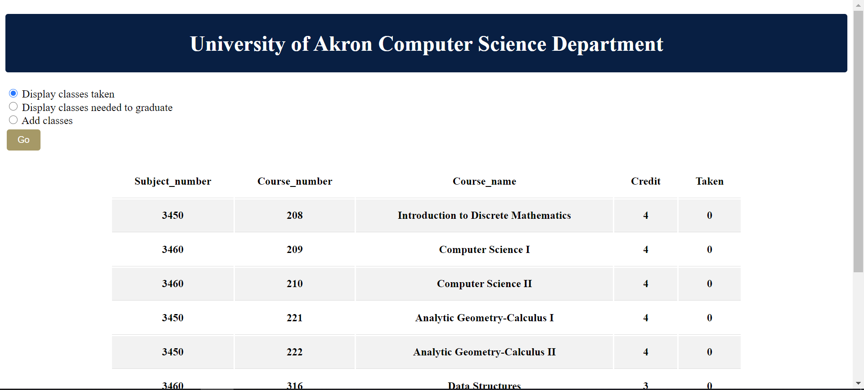

**Figure 5a and 5b: Main.php display classes and electives needed to graduate**

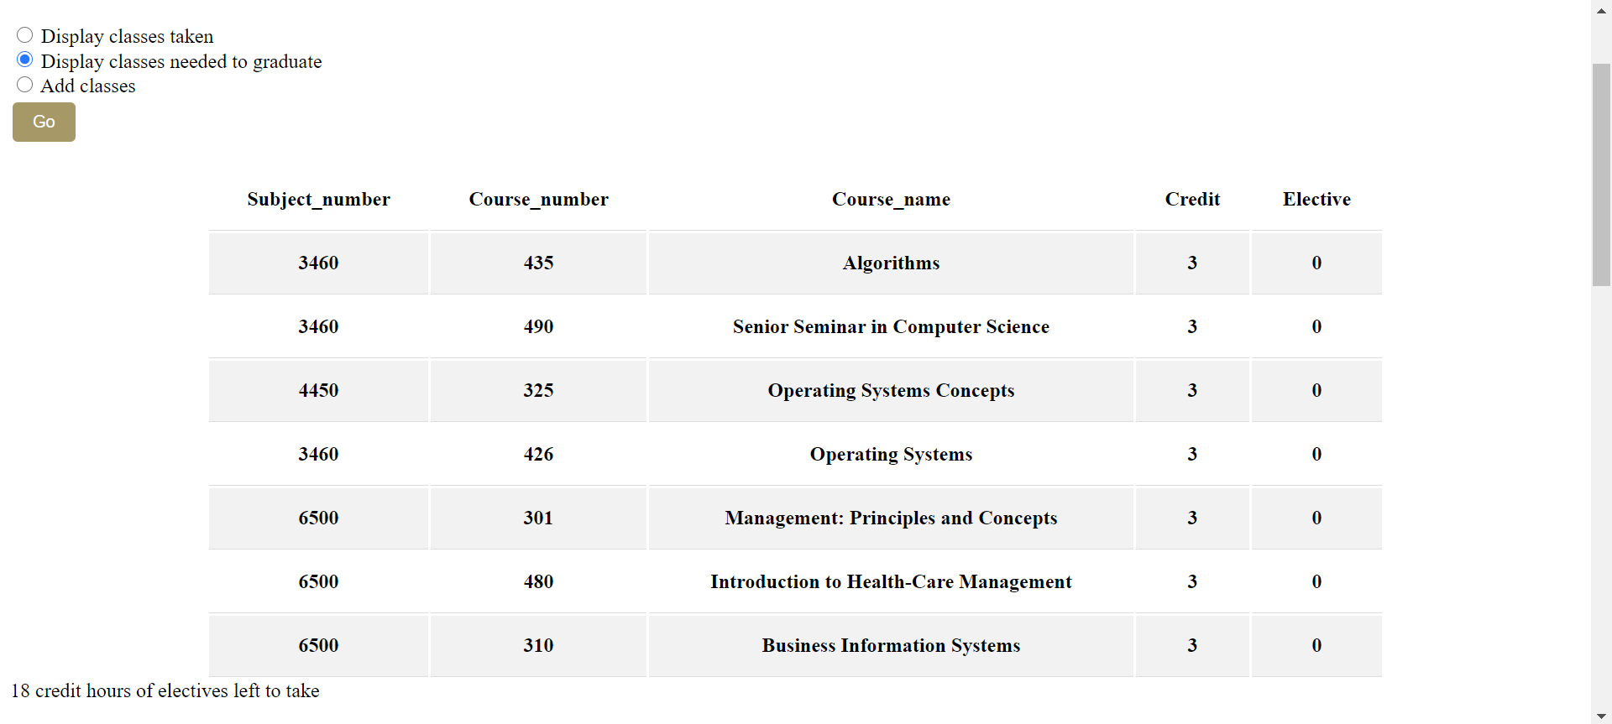

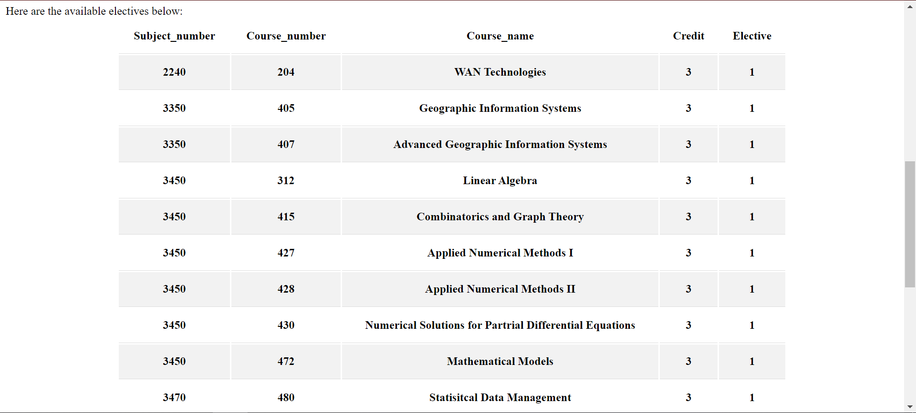

**Figure 6a and 6b: Main.php add classes taken**

